Capability Maturity Model Integration

Capability Maturity Model Integration (CMMI) is a process level improvement training and appraisal program. Administered by the CMMI Institute, a subsidiary of ISACA, it was developed at Carnegie Mellon University (CMU). It is required by many U.S. Government contracts, especially in software development. CMU claims CMMI can be used to guide process improvement across a project, division, or an entire organization.

Casestudy: <https://www.cio.com/article/274530/cmmi-explained.html>

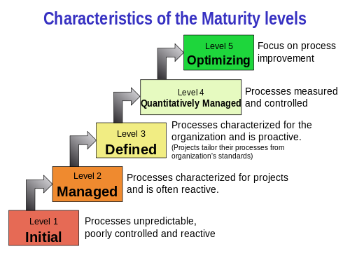

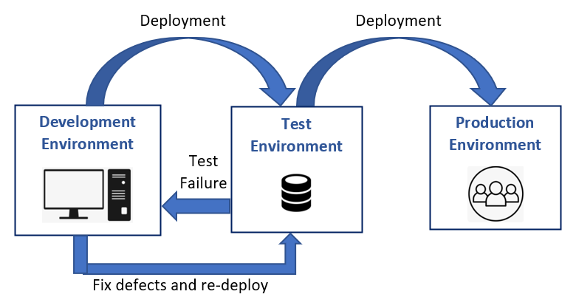

Environment planning is crucial for ensuring that each stage of development, testing, and deployment is well-structured and managed. Here's an overview for each environment:

1. **Development (Dev)**:
   * **Purpose**: This is where developers write and initially test their code.
   * **Characteristics**:
     + Fast feedback loop.
     + Frequent code changes and updates.
     + Access to debugging tools.
   * **Considerations**: Ensure that developers have all necessary tools and dependencies.
2. **Testing (Test)**:
   * **Purpose**: To run initial automated tests on new code to catch bugs early.
   * **Characteristics**:
     + Isolated from the development environment.
     + Automated testing frameworks in place.
     + Test data that mimics real data but isn't sensitive.
   * **Considerations**: Maintain up-to-date test scripts and ensure test data integrity.
3. **Quality Assurance (QA)**:
   * **Purpose**: More rigorous testing including manual and automated testing by a QA team.
   * **Characteristics**:
     + Mimics the production environment as closely as possible.
     + Extensive test cases covering various scenarios.
     + Involves performance, security, and usability testing.
   * **Considerations**: Ensure that the environment is stable and consistent for accurate testing results.
4. **Pre-Production (Preprod)**:
   * **Purpose**: Final stage of testing before deployment to production.
   * **Characteristics**:
     + Closely mirrors the production environment.
     + Used for final acceptance testing and validation.
     + Involves stakeholder review and sign-off.
   * **Considerations**: Ensure that all configurations match production settings.
5. **Production (Prod)**:
   * **Purpose**: Live environment where the application is accessible to end-users.
   * **Characteristics**:
     + High availability and reliability.
     + Monitoring and alerting systems in place.
     + Strict access control and security measures.
   * **Considerations**: Ensure thorough monitoring, backup strategies, and incident response plans.

**General Planning Considerations**

* **Configuration Management**: Use tools like Ansible, Puppet, or Chef to manage environment configurations consistently.
* **Version Control**: Keep all environment configurations under version control (e.g., Git) to track changes and ensure consistency.
* **Continuous Integration/Continuous Deployment (CI/CD)**: Implement CI/CD pipelines to automate the build, test, and deployment processes.
* **Monitoring and Logging**: Ensure robust monitoring and logging for all environments to quickly identify and resolve issues.
* **Security**: Apply security best practices at every stage, including data encryption, access controls, and regular security audits.
* **Documentation**: Maintain comprehensive documentation for each environment, including setup instructions, configurations, and maintenance procedures.